**13. Develop a system using UML for BPO Management System. The system should hold the details of the customer and all approaches to it. It is managed by the central system.**

**Component Diagram :**

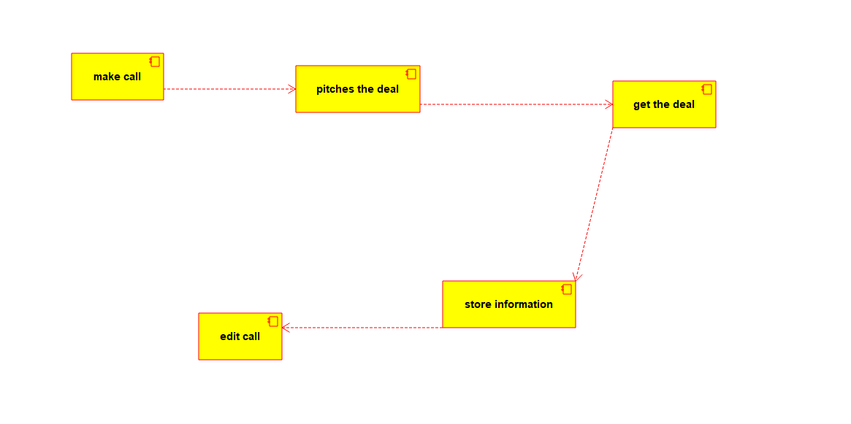

**Deployment Diagram :**

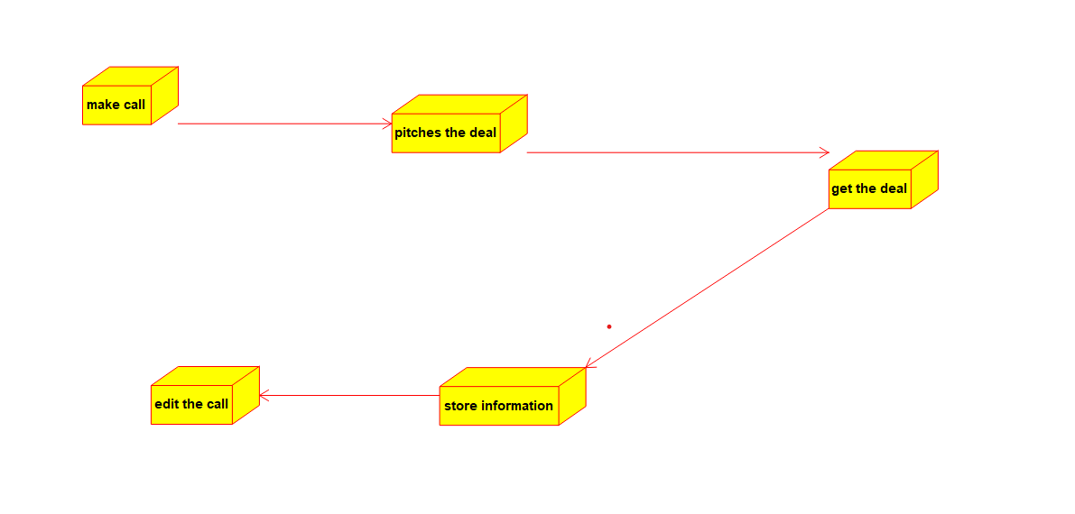

**State Diagram :**

